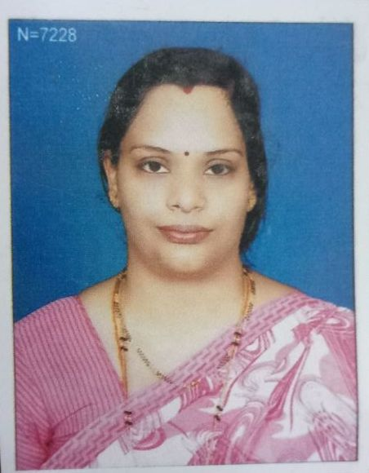
CURRICULUM VITAE

Name : SUDHA S. CHIKMATH
Address : Plot No-5 Opposite Arman Hall Vidyagiri 2nd Cross
Bauxite Road, Belagavi.
Date of Birth : 11/12/1983
Educational Qualification : MA (English), B.Ed.
Additional Qualification : Nil
Date of joining the institution : 08/06/2016
Present Designation : Lecturer
Award of M. Phil, Ph.D : Nil
Orientation/Refresher Courses/ : Orientation : Nil
Seminar/ Workshops/ Refresher Courses : Nil
Training attended Seminar Attended : 03
Workshops : 02
Training Attended : Nil
Paper Presented : 03
Details of Publications : Nil
Details of Extension Activities : Nil
Details of Consultancy Services : Nil
Details of Research Guide ship : Nil
Details of Award : Nil
Any other : Nil

