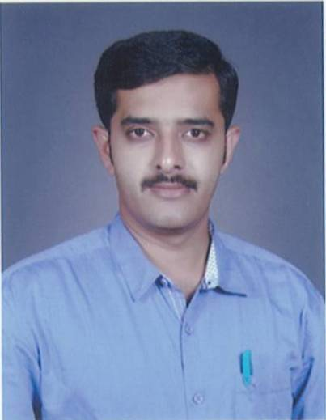
CURRICULUM VITAE

Name : SUDHIR S. SHANDAGE
Address : A/P: Morab TQ: Raibag Dist: Belagavi
Date of Birth : 24/06/1990
Educational Qualification : MA (English), B.Ed.
Additional Qualification : Diploma in Computer Teachers’ Training course
Date of joining the institution : 09/02/2017
Present Designation : Lecturer
Award of M. Phil, Ph.D : Nil
Orientation/Refresher Courses/ : Orientation : Nil
Seminar/ Workshops/ Refresher Courses : Nil
Training attended Seminar Attended : 04
Workshops : 02
Training Attended : Nil
Paper Presented : 04
Details of Publications : Nil
Details of Extension Activities : Nil
Details of Consultancy Services : Nil
Details of Research Guide ship : Nil
Details of Award : Nil
Any other : Nil

