CURRICULUM VITAE
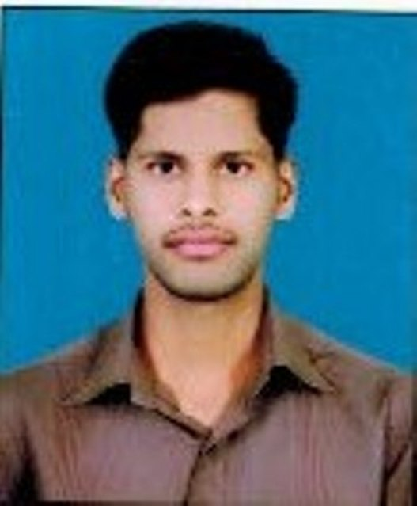

Name : Moazam Mulla

Address (Office) : Department of Commerce,
K.L.E. Society’s, Lingaraj College,
College Road, Belagavi-590001
Karnataka-India

Mobile : 9742340960
E-mail : moazamamulla@gmail.com

Date of Birth : 29th November 1991

Qualification : M.Com
Date of entry into service : 1st July 2016

Date of joining the institution : 1st August 2017

Present Designation : Lecturer in Commerce

Career Objective:
To begin my lecturer career at a highly-reputed and eminent educational institute and to gain exceptional career and to move ahead through dedicated efforts and performance regularity.
Academic Qualification :
Exam Passed | Board/ University | Subjects/ Specialization | Year | Percentage | Division/ Grade Merit etc.,
Master’s Degree  M.Com. | Rani Channamma University, Belagavi | Commerce- Taxation & Accounting | 2015 | 72.25 | FIRST CLASS
Bachelor’s Degree  B.Com. | Karnataka University Dharwad | Commerce | 2012 | 72.13 | DISTINCTION
PUC II | PU Board, Bangalore |  | 2009 | 52.66 | SECOND CLASS
S.S.L.C | KSEEB |  | 2007 | 77.44 | DISTINCTION

Experience: 3 years completed.

Seminars, Conferences, Symposia Workshops – Paper Presented
Seminars Attended:

Sl. No. | Name of the Seminar / Conference/ Symposia Workshop, etc., | Organized by | Place and Date
1. | Paper presented on “The role of commerce and management education in National Vision-2020” | KLE’s’ Basavaprabhu Kore Arts,Science and Commerce College, Chikodi, | Chikkodi
2. | Paper presented on “Indian Social Problems: The Challenges and the solutions” | KLES’ Lingaraj College, (Autonomous) Belagavi. | Belagavi  5th March 2014
3 | Paper presented on “Business can be done Ethically’’ | KLE Society’s  Lingaraj College, Belagavi | Belagavi  1st October,2014
4 | Papar presented on “To the Growth of Economy” | KLE Society’s  Lingaraj College, Belagavi | Belagavi  14thOctober, 2014.
5 | Paper Presented on “Globalization& Rural Development” | Department of studies in Economics, Rani Channamma University, Vidyasangam, Balagavi | Belagavi  27th& 28th, February 2015
6 | Paper Presented on “Micro Finance and Financial Inclusive” | Kittur Rani Channamma Education Society’s, G.G.D.Arts, B.M.P.Commerce and S.V.S.Science Degree College, Bailhongal | Bailhongal  2nd March 2015
7 | Paper presented on “Agri-Business in the Era of Globalization” | 12th Annual conference of Karnataka Economic Association, In KLES’Lingaraj College,(Autonomous) Belagavi. | Belagavi  30th and 31st March 2015
8 | Paper presented on “Human Resource Management” at the international conference on Current Experiments & Innovations in Commerce, Management, Languages and Social science, | Smt. Somavva C. Angadi, Govt. First Grade College, K.K.Koppa, Dist:Belagavi, INDIA. | K.K.Koppa  27 Sep, 2014
9 | Paper presented on “ Trends of Globalization in Business and Education Management” | KLES’ Basavaprabhu Kore Arts,Science and Commerce College, Chikodi | Chikodi  28th and 29th December, 2014.
10 | Paper presented on “New Trends And Challenges In Commerce. Sub Topic- Human Resource Management” | Maratha Mandal’s Arts, Commerce, Science and Home Science College, Belgaum, Karnataka, India. | Belgaum  4th April, 2015
11 | National Conference on “Role of Commerce And Management in Emerging Economies”.  Presented paper titled ”Human Resource Management”. | Department of Commerce and Management ShivajiUniversity Kolhapur | Kolhapur  16thand 17thMarch 2018

Workshops Attended:

Sl. No. | Name of the Seminar / Conference/ Symposia Workshop, etc., | Organized by / Name of the Sponsoring Agency | Place and Date
1. | Two-day Workshop On “Research Methodology” | KLES’ Lingaraj College,(Autonomous) Belagavi | Belagavi  12th and 13th December 2014

(Moazam Mulla)

