CURRICULUM VITAE
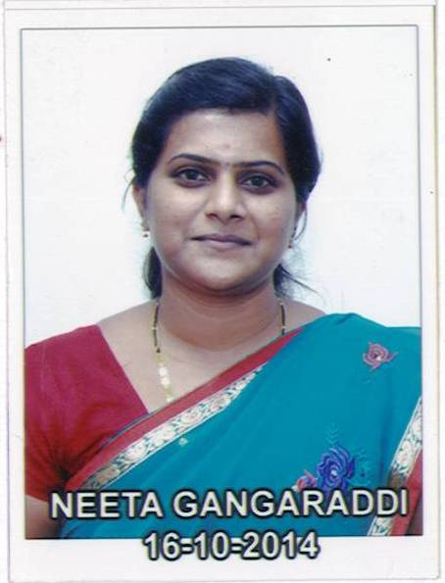

Name :
Address (Office) : Department of Commerce,
K.L.E. Society’s, Lingaraj College,
College Road, Belagavi-590001
Karnataka-India

Mobile : 8722739635
E-mail : neeta.gangaraddi@gmail.com

Date of Birth : 13-10-1987

Qualification : M.Com
Date of entry into service : 2nd August 2010

Date of joining the institution : 1st July 2014

Present Designation : Head, Department of Commerce

Career Objective
“Seeking an environment that will serve as a platform to learn and enhance my skills where in my knowledge and my experience can be shared and enriched. Working in a progressive work culture with the freedom to be creative, innovative and to excel and grow with the organization”

Academic Qualification:
EXAMINATION PASSED | BOARD / COUNCIL | YEAR OF PASSING | PERCENTAGE | DIV. / CLASS
S. S. L .C. | Karnataka Secondary Education Examination Board | 2003 | 76% | First Class
Pre University | Department of Pre-University Education | 2005 | 78% | First Class
Graduation in Commerce | Karnataka University Dharwad | 2008 | 80% | First Class With Distinction
Post Graduation in Commerce | Karnataka University Dharwad | 2010 | 73% | First Class with Distinction

Teaching Experience: 8 years

Seminars, Conferences, Symposia Workshops – Paper Presented
Seminars/Conferences /Symposia Attended details
Sl. No. | Name of the Seminar / Conference/ Symposia Workshop, etc., | Organized by | Place and Date
1. | Paper Presented in One day National level Seminar Values And Ethics In Marketing | Maratha Mandal College of Arts Science and Commerce Belagavi | 4th December 2013
2. | Paper Presented in One Day National Seminar on Foreign Direct Investment in Retail Marketing in India | B.V.V.Sangha’s  Basaveshwar Commerce College Bagalkot | 20th 21st September 2014
3 | Paper Presented in One Day National Seminar on Foreign Direct Investment in Retail Marketing in India | Maratha Mandal College of Arts ,Science and Commerce College Belagavi
4 | Papar presented on “To the Growth of Economy” | KLE Society’s  Lingaraj College, Belagavi | Belagavi  14thOctober, 2014.
5 | Paper presented on “ E-Human Resource Management” | International Conference organized Smt. Somavva C. Angadi, Govt. First Grade College, K.K.Koppa, Dist:Belagavi, INDIA. | K.K.Koppa  27 Sep, 2014.
6 | One day National level seminar on ‘Business and Ethics – Is there a linkage’ | Dept. of Commerce, Lingaraj College, Belgaum | Belgaum  1st Oct 2014.
7 | Paper presented on “ FDI In Indian Economy” | KLES’ Basavaprabhu Kore Arts,Science and Commerce College, Chikodi | Chikodi  28th and 29th December, 2014.
8 | Training Programme for Teachers | Lingaraj College, Belgaum | Belagavi August 2014.
9 | Faculty Development Programme | KLES’s RLS College, Belgaum | Belgaum  August 2014.
10 | Presented paper–“Role of Micro Finance in Development of Financial Inclusion” in One Day National Seminar on “Rural Credit and Inclusive Growth” | G.G.D Arts, B.M.P Commerce and S.V.S Science Degree College Bailhongal. | Bailhongal  2nd March 2015.
11 | Paper presented on “New Trends And Challenges In Commerce. Sub Topic- Human Resource Management” | Maratha Mandal’s Arts, Commerce, Science and Home Science College, Belgaum, Karnataka, India. | Belgaum  4th April, 2015.
12 | Faculty Development Programme on ‘Case Methodology of Teaching’ | IBS-ICFAI Business School. | Belagavi  21stAugust 2015.
13 | Paper presented in One Day National Level Seminar on Impact of Indirect Tax and Direct Tax “VAT” | Basaveshwar Commerce College, Bagalkot | 9th and 10th October 2015.
13 | Attended One day Symposium on “Climate change: challenges and Initiatives”. | K.L.E.Society’s  Lingaraj College, Belagavi. | Belagavi  29th February 2016.
14 | Attended One Day National Level seminar on “Healthy Mind in Healthy Body” | Department of Psychology and Physical Education Lingaraj College, Belagavi | Belagavi  12th April 2016.
15 | Presented paper in Two day International Conference on “Financial Inclusion in India” | Basaveshwar Commerce College, Bagalkot | 10th September 2016
16 | Paper Presented in National Conference on : Green Marketing | Shri Dharamastala Manjunatheshwara , Post Graduation Centre, Management Studies and Research,Mangaluru | 24th February 2018.

Workshops Attended Details :

Sl. No. | Name of the Seminar / Conference/ Symposia Workshop, etc., | Organized by / Name of the Sponsoring Agency | Place and Date
1. | Two-day Workshop On “Research Methodology” | KLES’ Lingaraj College,(Autonomous) Belagavi | Belagavi  12th and 13th December 2014
2 | One Day Workshop on “Interpersonal Skill”. | Organized by Dept of P. G. Studies in Commerce K.L.E.’s Lingaraj College, (Autonomous), Belgavi. | 13th Sept. 2017.
3 | One Day Workshop on “Stock Market” 10th October 2017. | Organized by Dept of P. G. Studies in Commerce, At Geojit Financial Services Ltd., Belagavi. | 10th October 2017.
4 | One Day Workshop on “Course Evaluation On Education in Technology” organized by KLE’s Lingaraj College (Autonomous), Belagavi. | Organized by KLES’s Lingaraj College (Autonomous), Belgavi.
5 | One Day National Level Workshop on “Cyber Laws and Ethics in India” | Organized by  B.V.Bellad Law  College,Belagavi | 23rd March 2018

