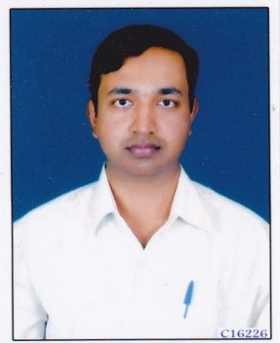
CURRICULUM VITAE
Name : Prashant S. Sidnal
Address : P.S.Sidnal
Pl.no.17 Shriram Nagar
At/Pt Mutaga
PIN CODE: 591124

Date of Birth :05/01/1984

Objective : “To take on the challenge to teach English
Language and Literature to Post graduate
Students”

Educational Qualification : P.G. in English & U.G. from
K.L.E.S’S
Lingaraj College Belagavi,
Karnatak University,Dharawad

Additional Qualification : Passed Certificate Course in Computer
Basic Computer , C, C+

Date of entry into service : 01/08/2010

Date of joining the institution : 07/02/2018

Present designation : Lecturer

Year of award of M.Phil/Ph.D : M.Phil. Year of award 27/09/2011
& Thesis title “ Henry James As A Critic : A Study”
: Ph.D. Year of award 12/03/2018
“Chitra Banerjee Divakaruni and Jhumpa
Lahiri as the women Writers of the Indian Diaspora”

Orientation /Refresher courses/ : Orientation : Nil
Seminar/Workshops/Training Refresher courses : Nil
Attended Seminar attended : 08
Workshops : 05
Training Attended : Nil

Paper presented : National – 09

Details of Publication : National – 02 , International – 08.
With ISBN NO : 978-93-83871797
ISSN NO : 0976-299X

Details of Extension activities/ : “Help age India” for creating awareness
Social activites and assisting in raising funds for the
care of the elderly, irrespective of race,
religion,cate or creed.

Details of Consultancy Services : Nil
Details of Research Guideship : Nil
Details of Award : Nil
Any other : Nominated as a member (Alumni) to the Board of Studies in English (PG)
K.L.E.S’S Lingaraj College,Belagavi

