CURRICULUM VITAE
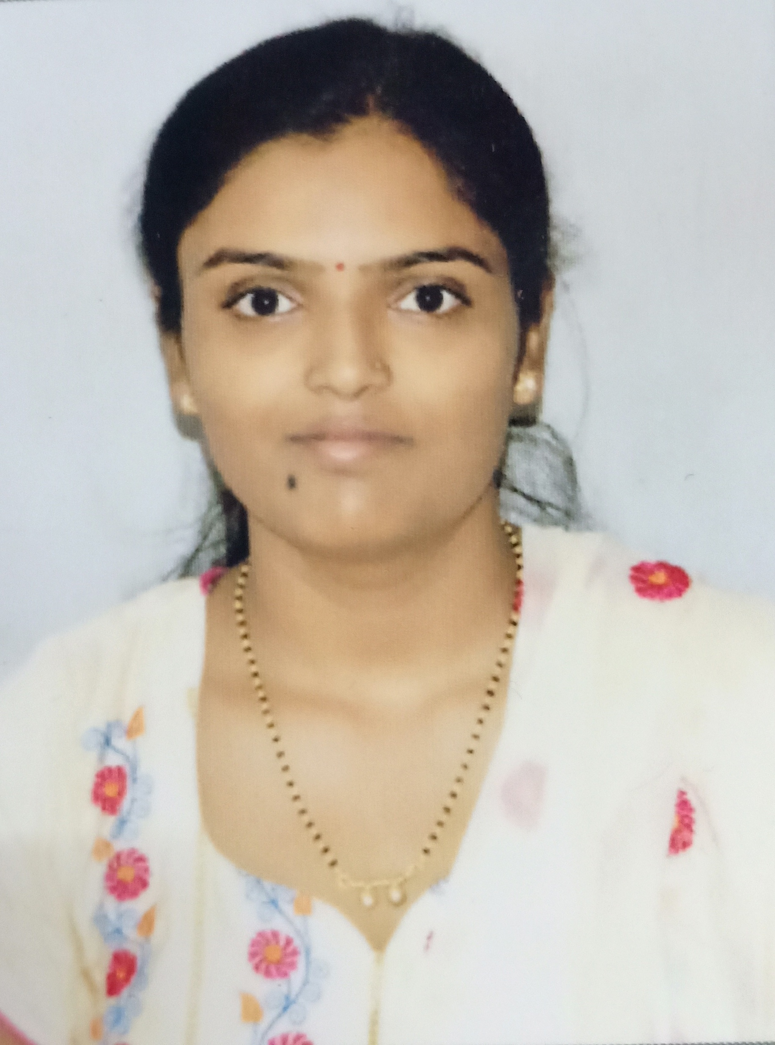

Name : Smt. Annapurna M. Tuppad
Address : Smt. Annapurna M. Tuppad
W/O: Rudrappa B. Gujanatti,
Plot No: 166, Ramteerth Nagar, Belagavi
590016
Mobile : 9742180671
E-mail : annapurna.t1@gmail.com
Date of Birth : 03-04-1989
Qualification : M.Com (PhD)
Date of entry into service : 17th September, 2012
Date of joining the institution : 8th June, 2018
Present Designation : Lecturer, Department of Commerce

Career Objective
“To serve in an educational institution for pursuing a career in teaching that provides an atmosphere where I can apply and update my skills”.

Academic Qualification
Qualifying Exam | Board/University | Year of Passing | Percentage | Division/Class
Post Graduation in Commerce | Rani Channamma University, Belagavi | 2012 | 80.95% | First Class with Distinction
Graduation in Commerce | Karnataka University, Dharwad | 2010 | 80.69% | First Class with Distinction
Pre University | Department of  Pre University Education | 2007 | 82% | First Class
SSLC | Central Board of Secondary Education, New Delhi | 2005 | 62.8% | First Class
Teaching Experience:
5.2 years

Seminars, Conferences, Symposia, Workshops and FDP – Attended

Sl. No. | Name of the Seminar / Conference/ Symposia Workshop, etc., | Organized by | Date
1. | One day FDP on Innovative Approaches in Teaching in the Outcome Based Education Era | BET’S Global Business School , Belagavi | 22ndJune, 2018
2. | National Human Rights Commission Sponsored One Day Training Program on Women’s Rights | BLDEA’SA.S.PatilCollege of Commerce  (Autonomous), Vijaypur | 11thOctober,2017
3 | One day International Conference on Humanities, Science, Technology and Environment | Anjuman Arts, Science and Commerce College and P.G. Studies in English, Vijaypur | 28thAugust, 2017
4 | Seminar on Intellectual Property Rights Sponsored by Indian Patents Office | BLDEA’S SSM College of Pharmacy and Research Centre, Vijaypur | 20th March, 2017
5 | UGC Sponsored One Day National Level Seminar on “India’s Potential to be the next Super Power” | BLDEA’SA.S.PatilCollege of Commerce  (Autonomous), Vijaypur | 19th March, 2016
6 | UGC Sponsored Two Days National Level Seminar on “Teacher Education in the Present Scenario” | BLDEA’S JSS College of Education, Vijaypur | 19th -20th September, 2014
7 | UGC Sponsored National Level Seminar on “Leading Issues in Indian Economic Policy” | Department of Studies in Economics,Akkamahadevi Women’s University, Vijaypur | 25th -26th March, 2014
8 | UGC Sponsored Two Days National Level Seminar on “Accounting Standards and Practices A Dialogue with Professional Bodies | BLDEA’SA.S.PatilCollege of Commerce  (Autonomous), Vijaypur | 19th -20th October, 2012
9 | State Level Seminar on “Teacher Competencies Contributing to Quality in Higher Education” | BLDEA’S Arts and Commerce College for Women, Vijaypur | 14th October, 2011
10 | Published paper entitled “GST in India-Challenges and Prospects” in Taxation in India under GST: Scope and Supply. | -

Workshops Attended Details:

Sl. No. | Name of the Workshop | Organized by / Name of the Sponsoring Agency | Date
1. | Ten Days Workshop on “Research Methodology and Statistical Analysis” | Department of Library and Information Science, Akkamahadevi Women’s University, Vijaypur | 18th-27th September,2017
2 | UGC Sponsored One Day State Level  Research Workshop on “FDP on Teaching, Learning and Evaluation” | BLDEA’SA.S.PatilCollege of Commerce (Autonomous), Vijaypur | 18th January, 2015
3 | UGC Sponsored Two Days National Level Research Workshop on “Research Methodology” | BLDEA’SA.S.PatilCollege of Commerce (Autonomous), Vijaypur | 19th-20th October, 2012

