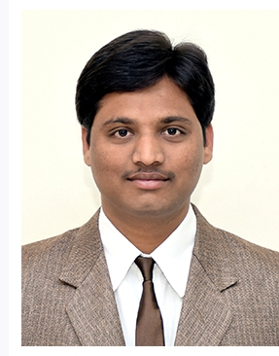
CURRICULUM VITAE
Name : VINAYAK B.KAMKAR
Address : #8, ‘Shri Banashankari Nilay’
Near Banashankari School
Samruddhi Colony,
Anagol Road
Belagavi-590011

Date of Birth : 11/11/1991

Educational Qualification : M.A. (Economics) B.Ed.
Karnatak University, Dharawad

Additional Qualification :
- Diploma in Hardware and Networking
- Microsoft Certified Professional (MCP) Windows 2003 Server

Date of entry into service : 19/12/2016

Date of joining the institution : 19/02/2018

Present designation : Lecturer in Economics

Year of award of M.Phil/Ph.D :

Orientation /Refresher courses/ : Orientation : Nil
Seminar/Workshops/Training Refresher courses : Nil
Attended Seminar attended : 08
Workshops : 01
Training Attended : 01

Paper presented : 04

Details of Publication :

Details of Extension activities/
Social activities :
- Participated in a Program “Role of Colleges in Taking Karnataka Towards 100% Voluntary Blood Donation Held at RCU, Belagavi.
- Served as NSS Volunteer at RCU, Belagavi.
- Attended a NSS Adventure Camp Held at Himachal Pradesh and Awarded as the Best Leader for the year 2011 – 2012

Details of Consultancy Services : Nil
Details of Research Guide ship : Nil
Details of Award : Nil
Any other :

