K.L.E. Society’s


Lingaraj College, Belagavi
(Autonomous)

Toppers in M. A. English Examinations, January-2020

M. A. in English I Semester
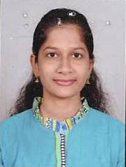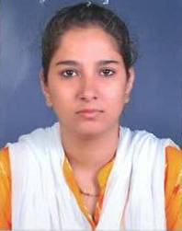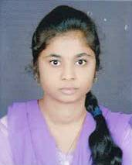
Bhagyashree T Patil Seefakausar attar Shweta Mudhol
I Rank 74.33 % II Rank 71.50% III Rank 70.00%

M. A. in English III Semester

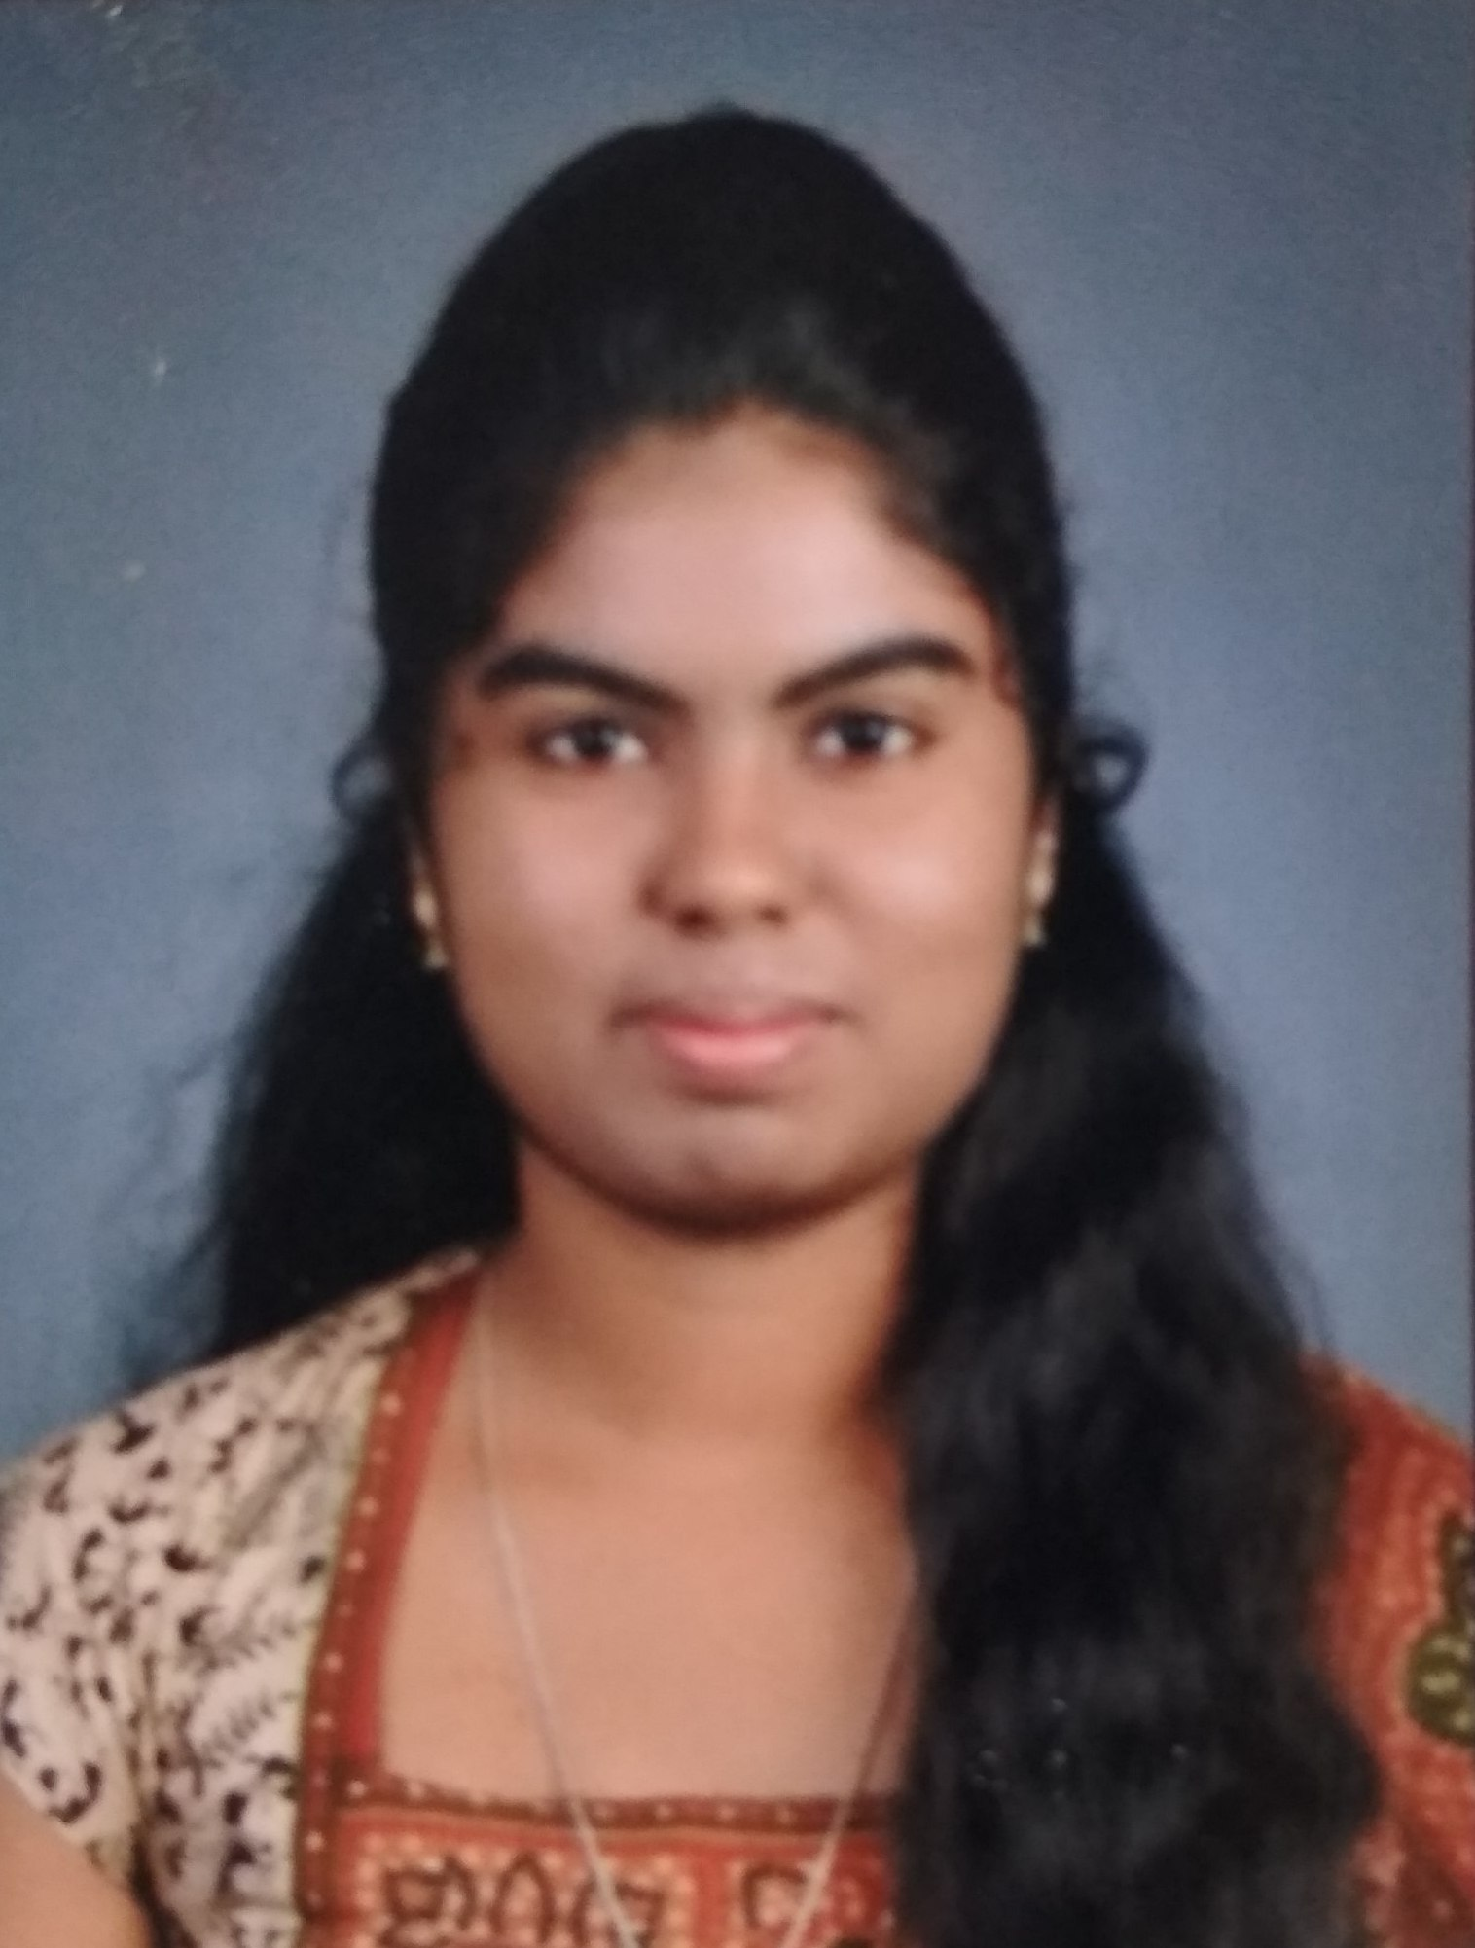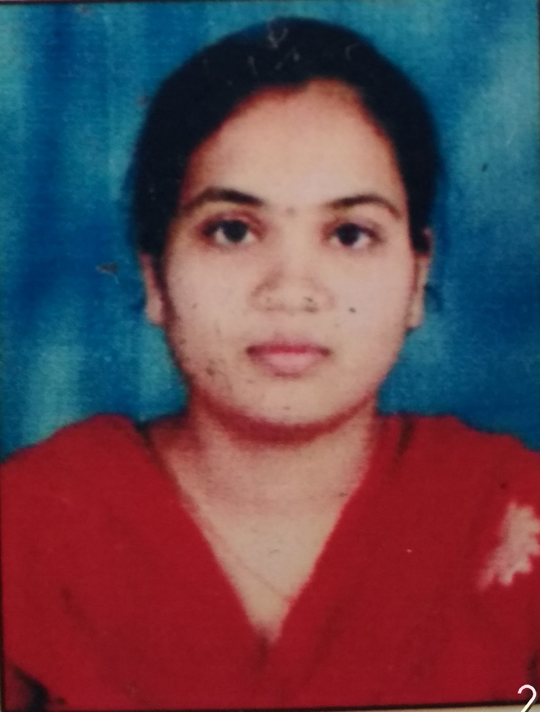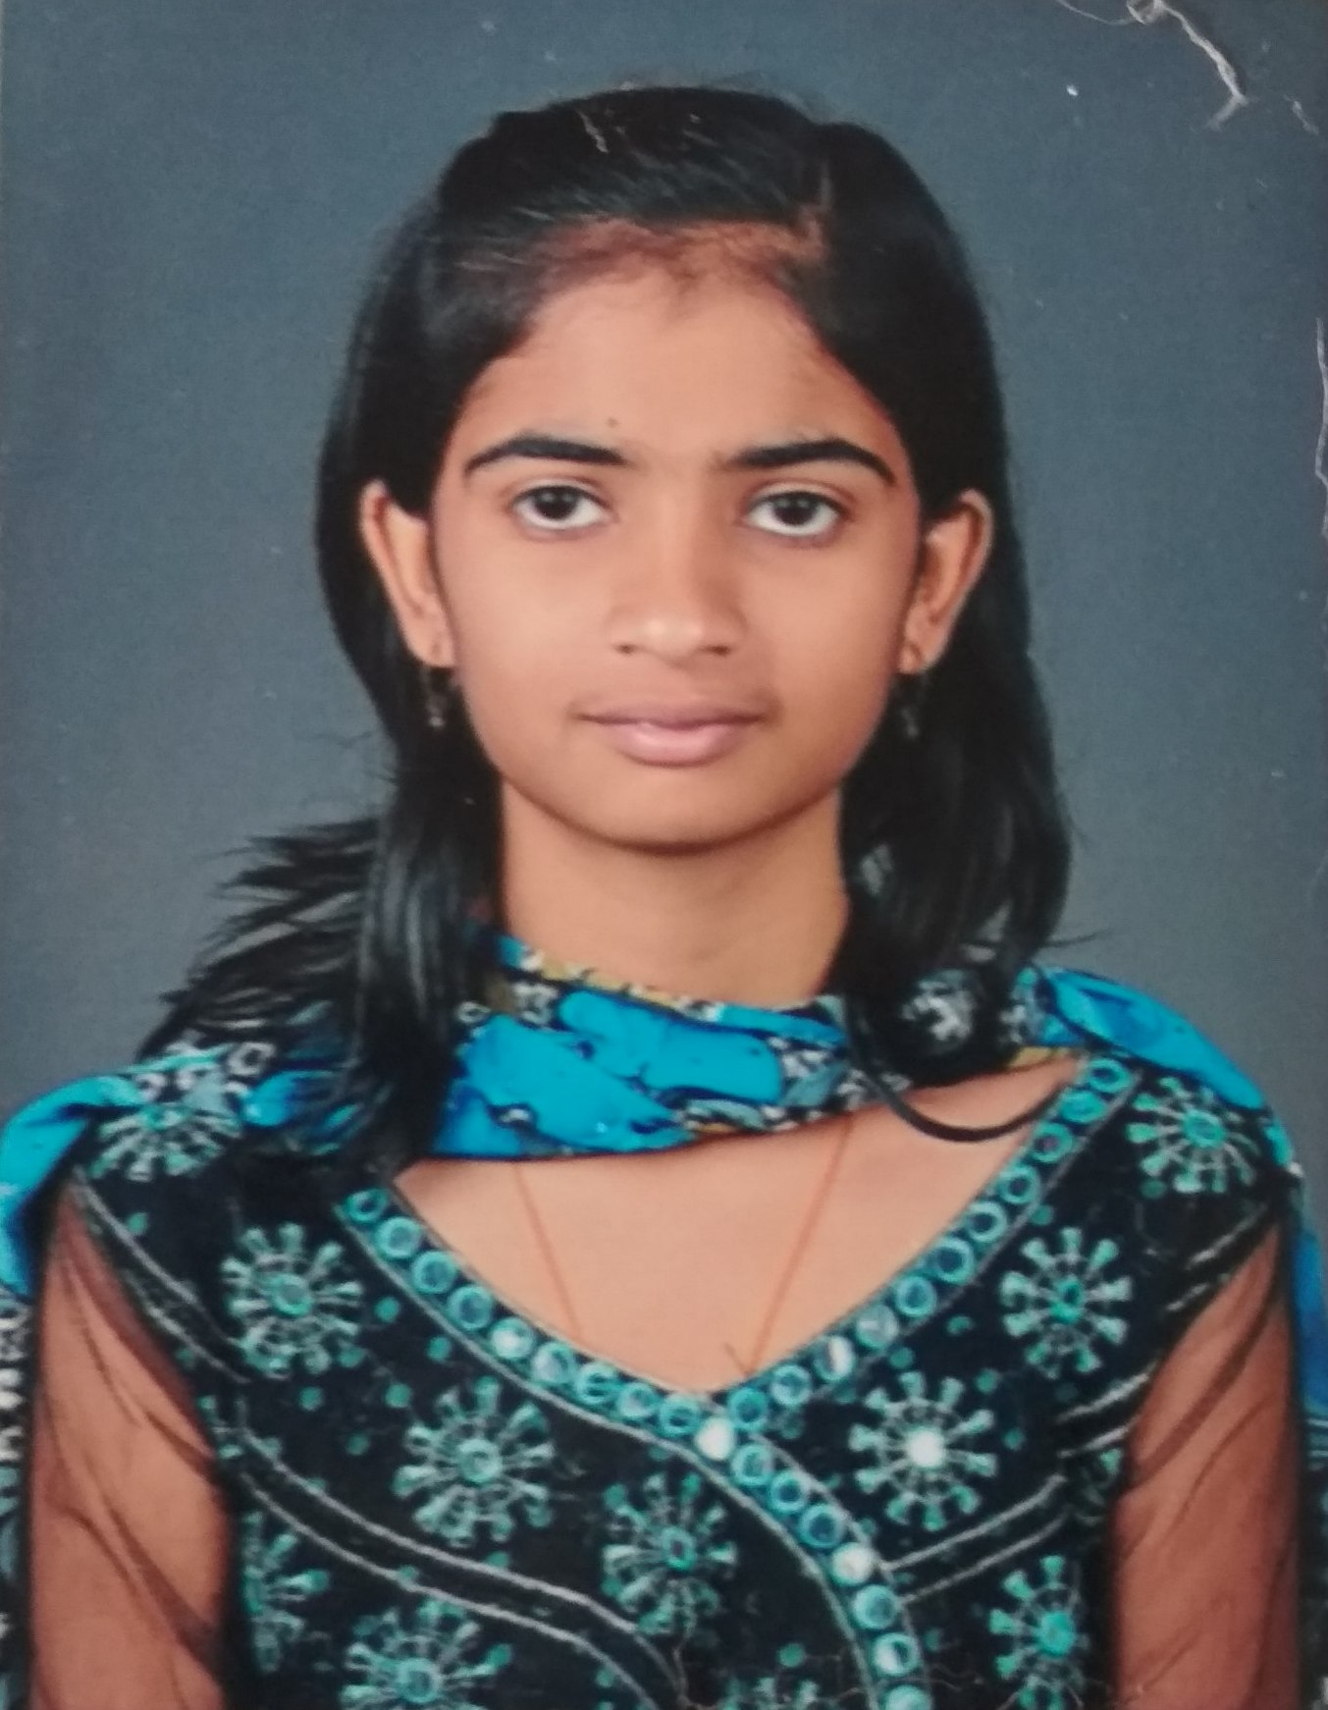
Rita V Banagar Uma Dhavan Shilpa Vinod Patil
I Rank 81.00 % II Rank 74.00 % III Rank 70.83%

Toppers in the M. A. Economics Examinations, January-2020
M. A. in Economics I Semester
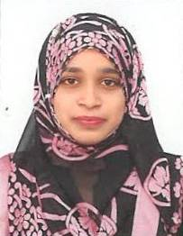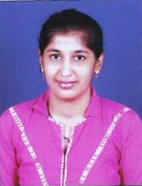
Basavaraj S Kudlennavar Shaikh Minaz Khaja Shivani D Bidari
I Rank 74.33% II Rank 73.50 % III Rank 72.17 %

M. A in Economics III Semester

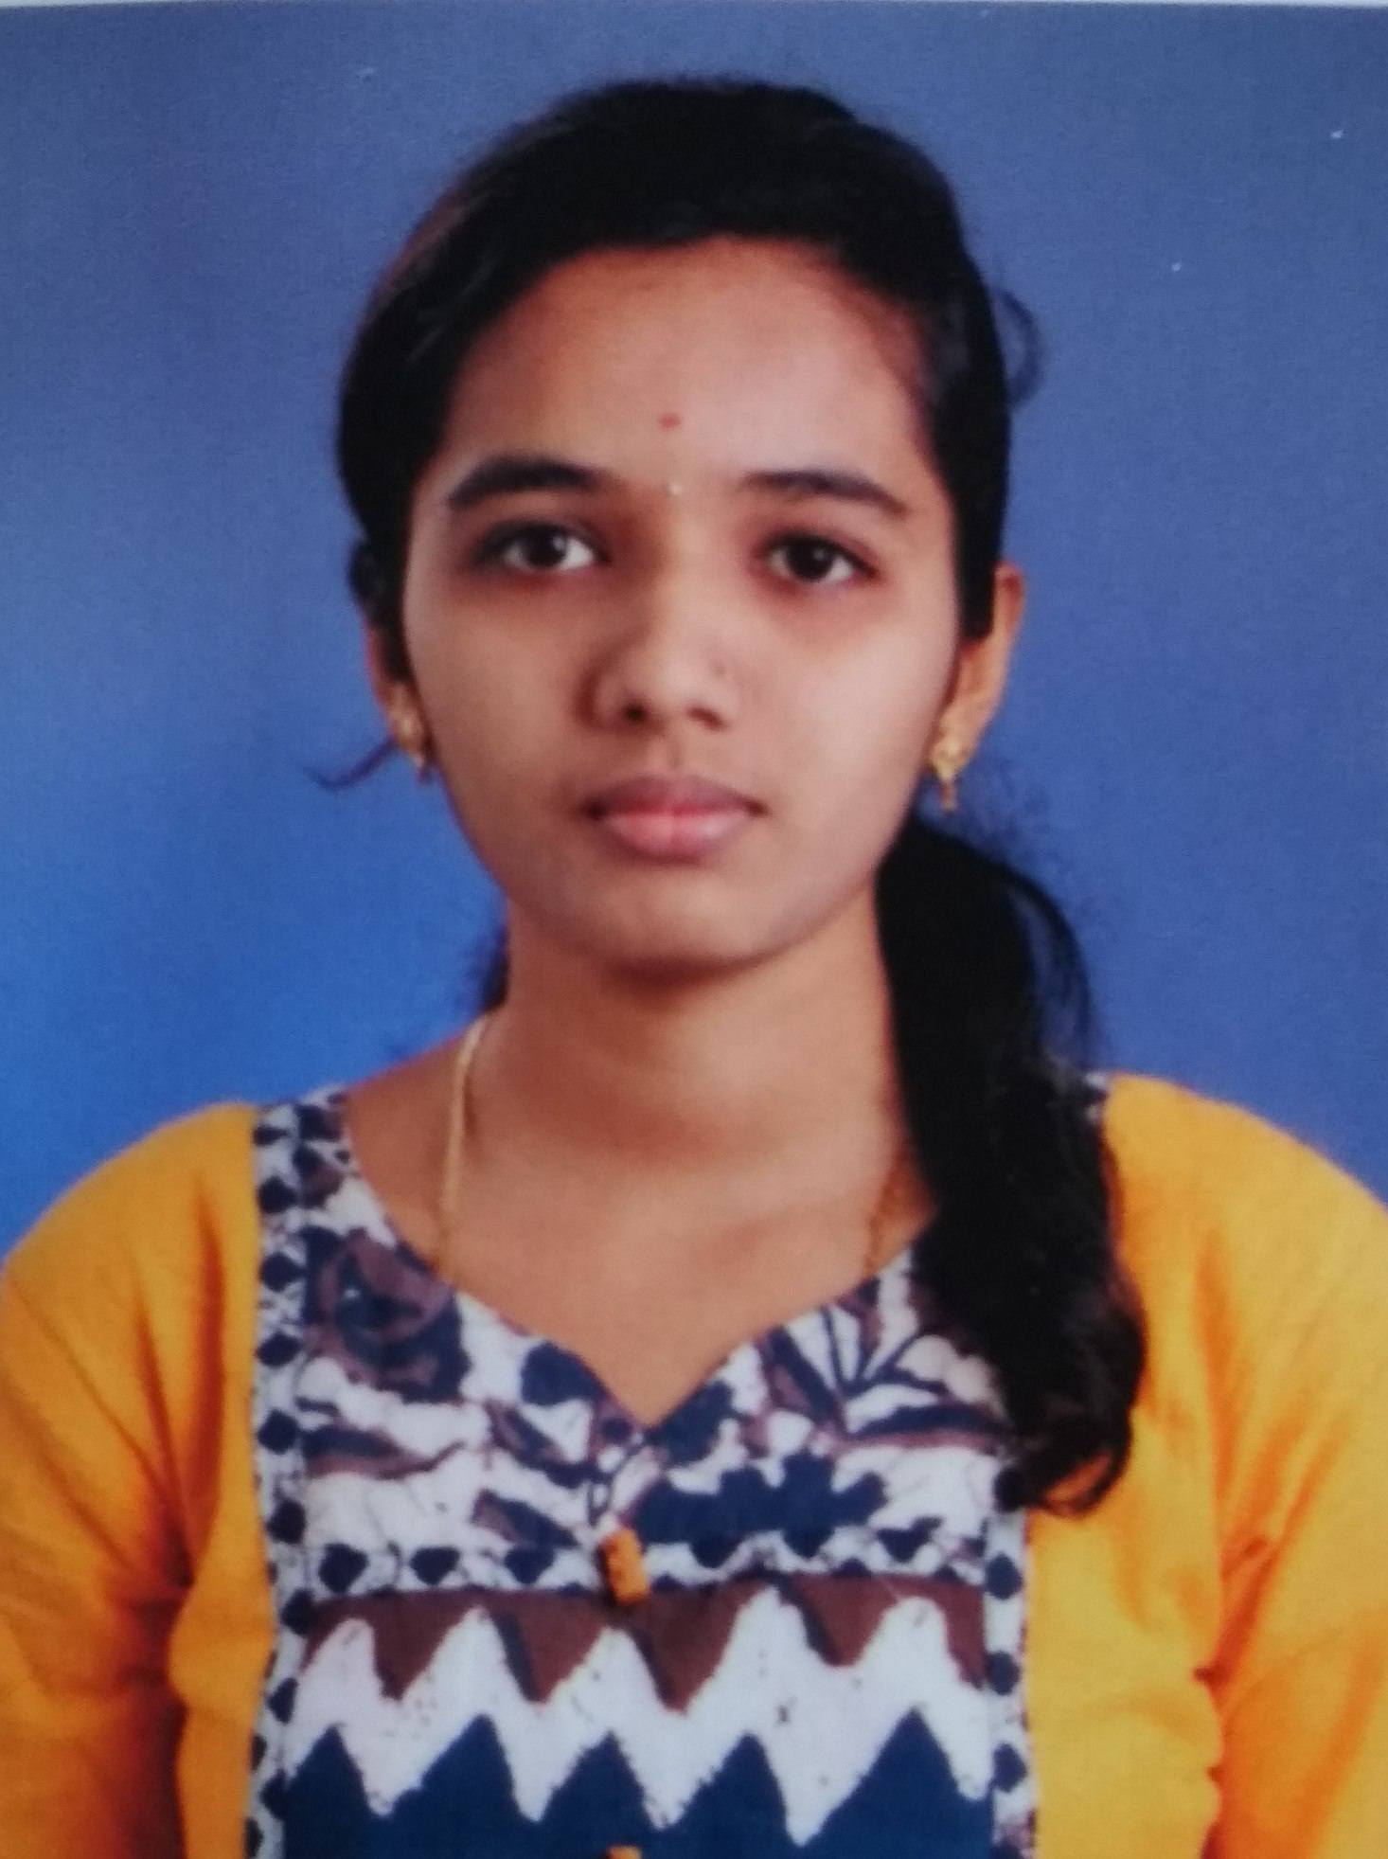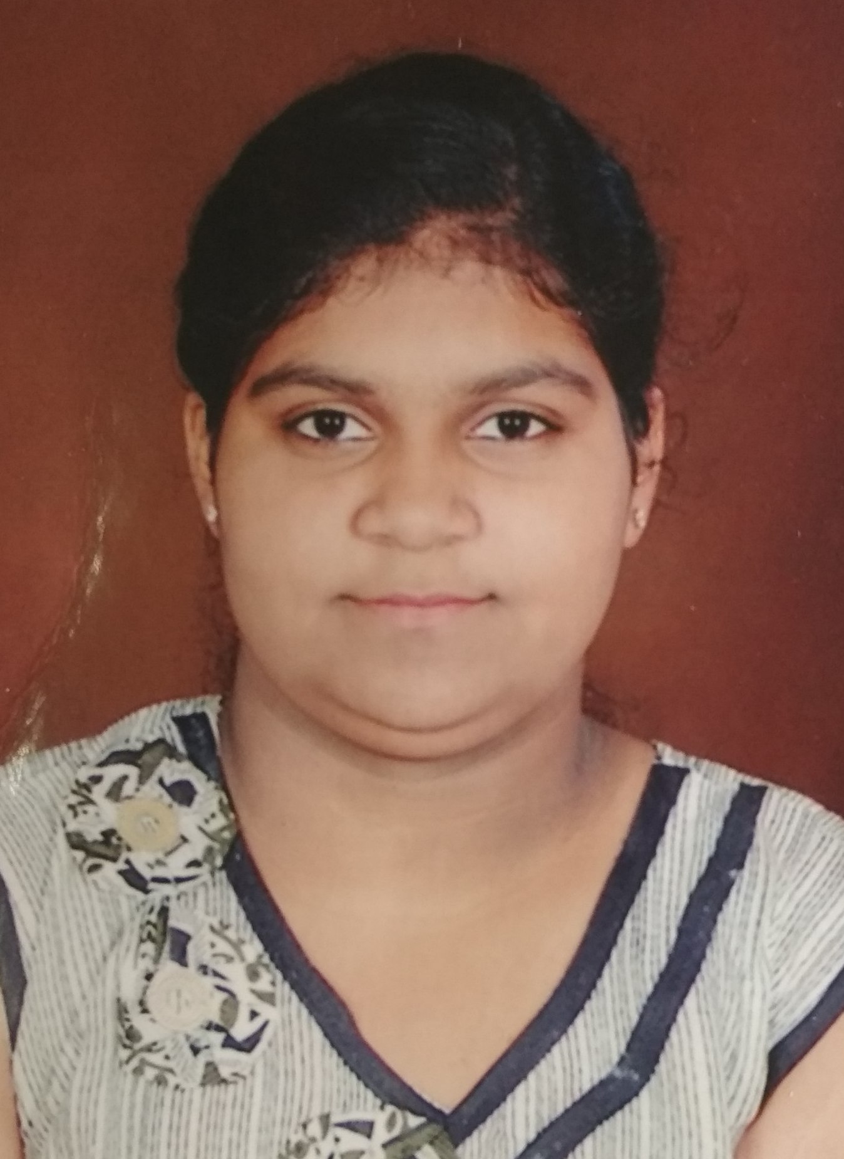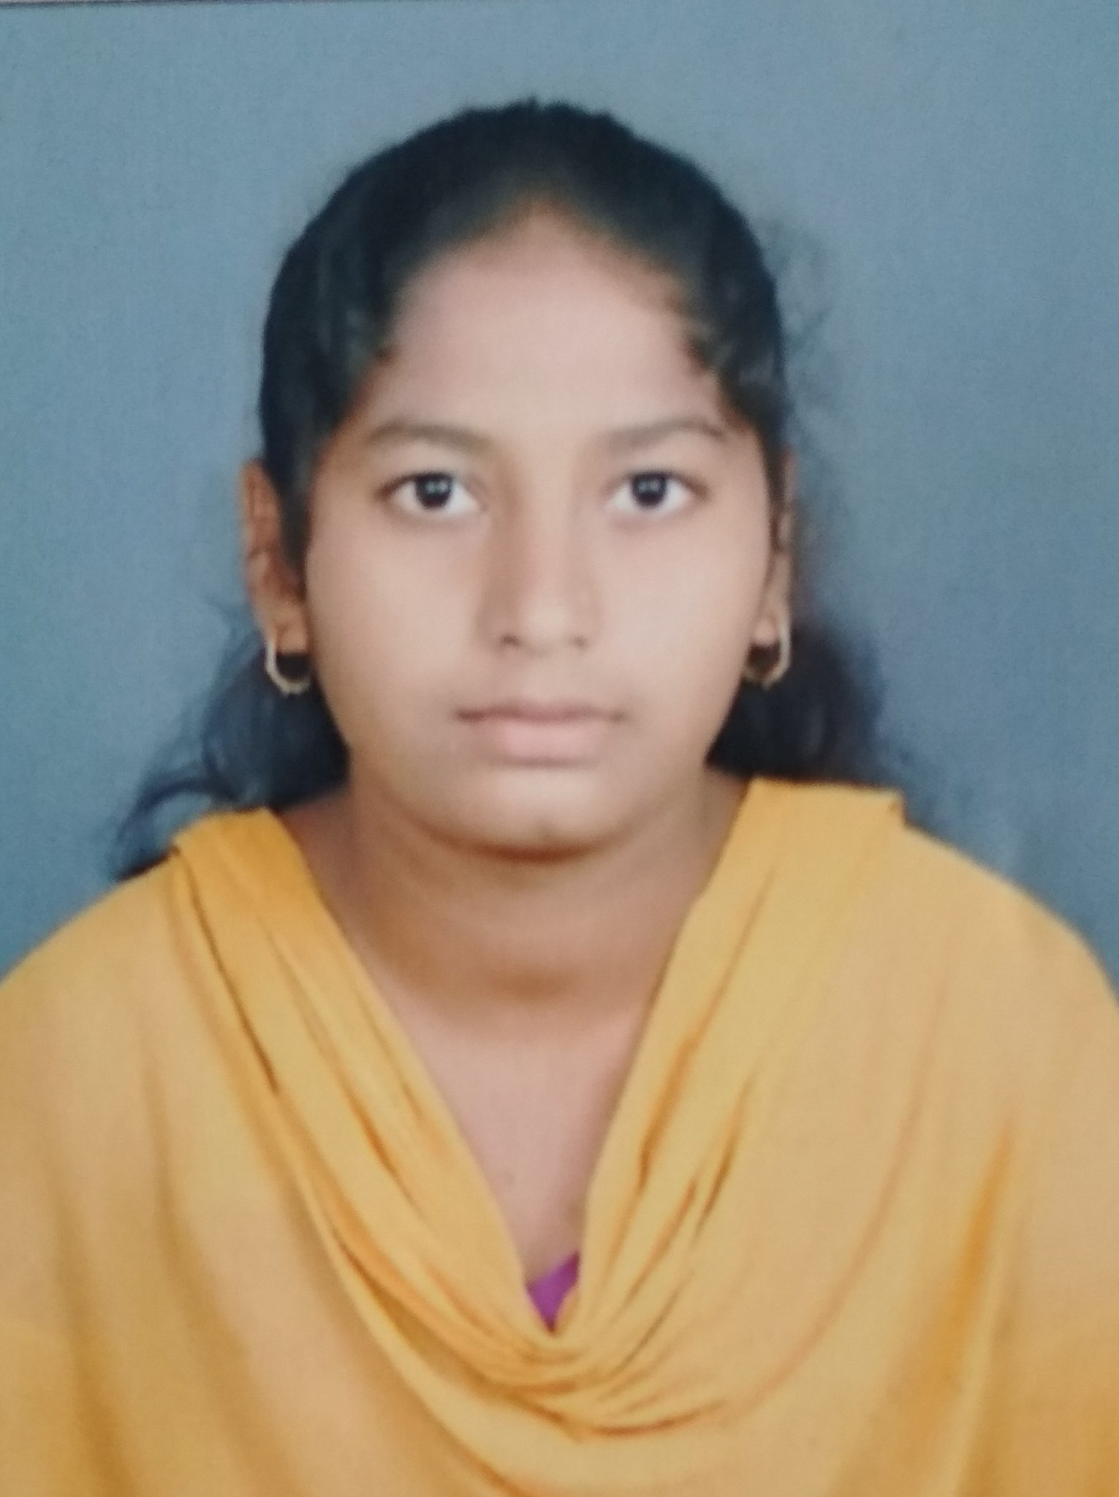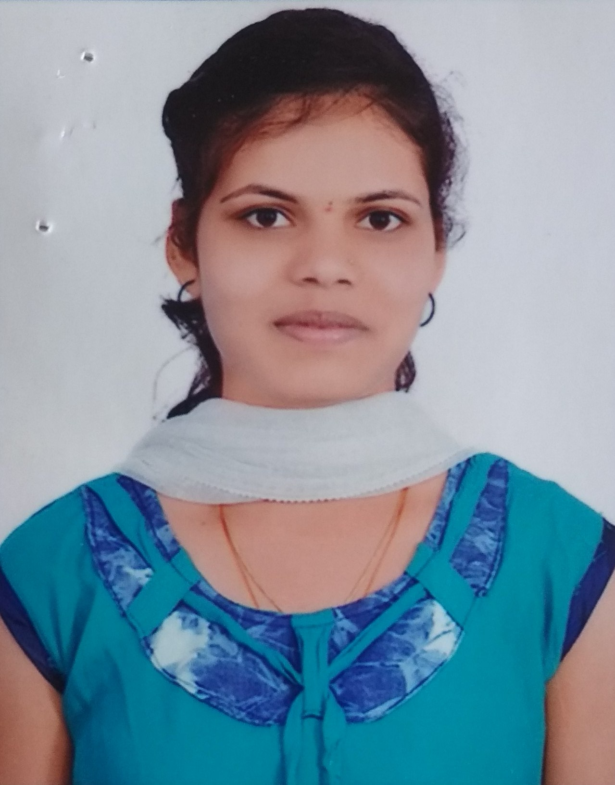
Shreedevi K Adalatti Aishwarya A Desai Arati Jakkannavar Siddamma Nadagouda
I Rank 79.33 % II Rank 74.17 % III Rank 73.33 % III Rank 73.33 %

K.L.E. Society’s

Lingaraj College, Belagavi
(Autonomous)

Toppers in M. Com. Examinations, January-2020

M.COM I Semester
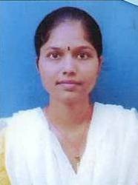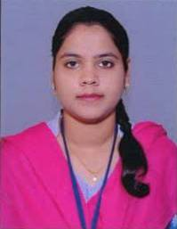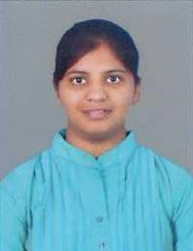
Shweta S. Hiremath Sadiya S.Maniyar Akshata Tandsi
I Rank 85.50% II Rank 80.50% III Rank 80.00 %

M.COM III Semester
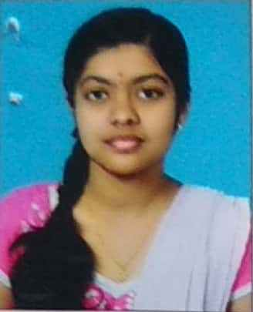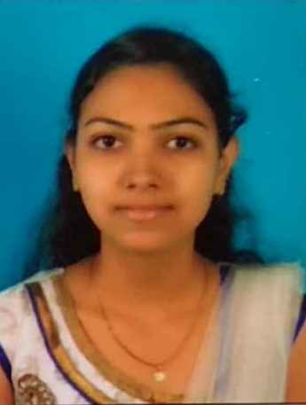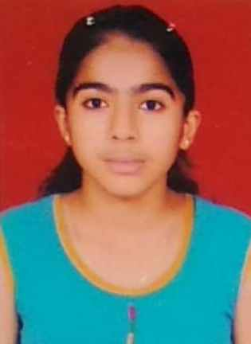
Shweta Uday Kulkarni Harshada Dhamanekar Mutagi Priya Savita
I Rank 80.83 % II Rank 78.67% III Rank 75.33%

